A Unified Framework for Verification & Improvement of LLM-Based Automated Unit Test Generation



Muhammad Abbas (BSE223183)

Syed Mukhtar-ul-Hassan (BSE223208)

Muhammad Hammad Ali (BSE223005)

Supervised By
Mr. Mudassar Adeel Ahmad

Fall 2025
Design Project-I
Department of Software Engineering
Capital University of Science & Technology, Islamabad
 | Project Proposal | 

VERSION |  | V X.0 |  |  | NUMBER OF MEMBERS | 03
TITLE | “A Unified Framework for Verification & Improvement of LLM-Based Automated Unit Test Generation.”
SUPERVISOR NAME |  |  | Mr. Mudassar Adeel Ahmad

MEMBER NAME | REG. NO. | EMAIL ADDRESS
Muhammad Abbas | BSE223183 | abbas63891@gmail.com
Syed Mukhtar-ul-Hassan | BSE223208 | shahmukhtar106@gmail.com
Muhammad Hammad Ali | BSE223005 | hammadmuhammad2288@gmail.com

MEMBERS’ SIGNATURES
Supervisor’s Signature

Approval Certificate

This project, entitled as “A Unified Framework for Verification & Improvement of LLM-Based Automated Unit Test Generation” has been approved for the award of

Bachelors of Science in Software Engineering

Committee Signatures:

Supervisor: __________________________

(Supervisor Name Dr / Mr / Ms)

Project Coordinator: __________________________

(Mr. Ibrar Arshad)

Head of Department: __________________________

(Dr. Nadeem Anjum)

Declaration
We hereby declare that the work presented in this project, “A Unified Framework for Verification & Improvement of LLM-Based Automated Unit Test Generation”, is the result of our original effort and has not been submitted, either in whole or in part, for any other degree or qualification at this or any other institution. All references to existing work, whether published or unpublished, have been duly acknowledged and cited to give proper credit to the original authors.
Furthermore, we affirm that this project complies with the ethical and academic standards established by Capital University of Science & Technology.

MEMBERS’ SIGNATURES

Acknowledgements
We would like to express our sincere gratitude to Mr.Mudassar Adeel Ahamd, Our Project Supervisor, for his guidance, encouragement and continuous support. His insights and constructive feedback played a crucial role in shaping our work and ensuring it.
We also extend our appreciation to Our University, for providing us with the necessary resources and a conductive environment to begin and complete our Final Year Project.

Table of Contents

Approval Certificate iii
Declaration iv
Acknowledgements v
Chapter 1 1
1. Introduction 1
1.1. Project Introduction 2
1.1.1. Problem Statement 2
1.1.2. Context and motivation 3
1.1.3. Scope and constraints 3
1.2. Existing Examples / Solutions 4
1.2.1. Identified shortcomings in existing solutions 5
1.3. Business Scope 6
1.4. Useful Tools and Technologies 8
1.5. Project Work Break Down 9
1.6. Project Time Line 10
References 12

List of Figures

Figure 1 overview Diagram 7
Figure 2 Work Breakdown Structure 11
Figure 3 Gantt Chart 13

List of Tables
Table 1-1Comparative Analysis oF Related Research 3
Table 1-2 Lean Canvas 8
Table 1-3 Tools and Technologies Used in the Project 10

This page is kept blank

Chapter 1

Introduction
Software testing ensures that software behaves as expected before deployment and includes several levels such as unit testing, integration testing, and acceptance testing. Integration testing validates how modules interact, while acceptance testing checks whether the system meets business and user requirements [16][17]. Although integration and acceptance testing have matured through automation frameworks like Selenium and Robot Framework [18], unit testing still requires significant manual effort and remains a bottleneck in development [1].
To reduce this effort, researchers have explored automated unit test generation using tools such as EvoSuite and Randoop, but these often produce unreadable or trivial tests [2]. The emergence of Large Language Models (LLMs) like GPT-3.5 (OpenAI) [19], CodeT5+ (Salesforce) [20], StarCoder (Hugging Face) [21], and Code Llama (Meta AI) [22] has opened new possibilities for generating unit tests that are readable and apparently useful tests. However, current LLM-based frameworks still suffer from issues such as poor handling of external dependencies, low repair effectiveness, and weak assertions are the limitations this project aims to overcome.
Despite this promise, LLM-based test generation still faces major challenges. Many generated tests fail to run due to missing external dependencies [1], contain weak or trivial assertions that fail to capture real faults [6], or show limited repair success when adaptive loops are applied [7]. While prior research has addressed individual issues, such as improving assertions [5], applying mutation testing [3], or reducing duplicate tests, existing solutions remain fragmented. This project proposes a unified framework that combines verification with improvement. By adding mocking support for missing external dependencies, repair loops, and a developer-friendly interface, framework focuses on making unit tests that work better and are more practical than current LLM-based ones as shown in figure 1.

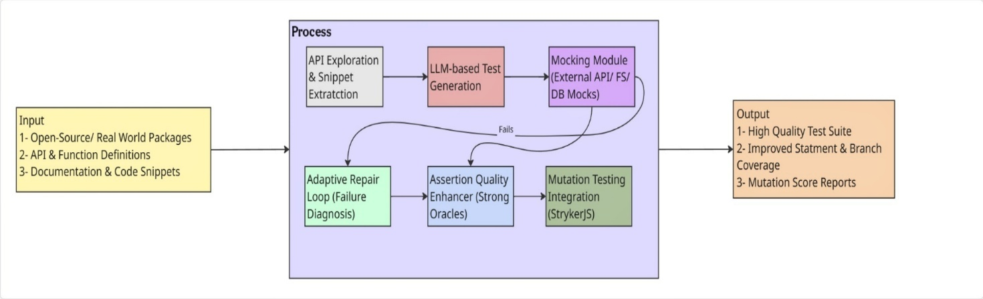
Figure 1 Overview Diagram

Project Introduction
The proposed project aims to produce a practical system that both verifies and improves unit tests generated by large language models (LLMs). It seeks to bridge the gap between automated test generation and real-world software quality assurance through practical testing and step-by-step improvement methods. The system integrates the following key components:
- Automated detection and mocking of external dependencies: Identifies APIs, databases, or file system calls and automatically inserts appropriate mocks or stubs.
- Multi-step adaptive repair loop with structured error diagnosis: Analyzes test failures and guides the LLM through an iterative, informed repair process.
- Assertion-quality enhancer: Detects weak or trivial assertions and strengthens them using semantic understanding and runtime behavior.
- Mutation-guided feedback mechanism: Uses mutation testing tools to measure and improve the real fault-detection ability of generated tests.
- Developer-oriented interface: Provides a user-friendly environment, such as a VS Code extension or web dashboard, enabling developers to review, validate, and refine generated tests interactively.
The framework aims to turn weak and automatically generated tests into stronger, simpler, and more useful test suites that developers can easily use in real projects while contributing to the research on integrating verification and improvement in LLM-based software testing..

Problem Statement
LLM-generated unit tests produce readable and apparently useful tests but are frequently unexecutable, weak at detecting real faults, and impractical for developer workflows. They break on code that uses external resources because automatic mocking is missing, repair loops fix only a small fraction of failing tests, assertions are often trivial, mutation-based fault detection is low, and existing tools lack an integrated developer-friendly interface.
There is a need for a unified framework that verifies LLM-generated tests to make them executable and fault-sensitive, and which simultaneously improves them through stronger assertions, and targeted test generation, while providing a seamless development environment for practical developer adoption.

Context and motivation
Recent work demonstrates that LLMs can produce unit tests and often outperform traditional automated test generators on coverage metrics; however, important limitations remain. The baseline study on LLM-based test generation (TESTPILOT) [1] showed promising statement/branch coverage gains but also highlighted persistent weaknesses: many generated tests fail in realistic environments due to missing mocks, a substantial fraction of failing tests are not successfully repaired by a simple adaptive loop (≈15% repair success reported), assertions are often trivial or weak, and mutation-based fault-detection remains lower than for human-written suites [1]. Independently, research on mutation testing [2], assertion generation[3], LLM-driven mutant creation, and JS-specific test generation provides partial solutions but typically addresses only one aspect (verification or improvement) [4], leaving a clear opportunity for a unified pipeline that combines both verification and improvement steps [5][6][7].

Scope and constraints
The project will focus initially on JavaScript / Node.js (the same ecosystem evaluated in the baseline study) because dynamically typed languages present high-value challenges such as type inference, and environment/dependency mocking [2]. Implementation will integrate existing tools where feasible (e.g., StrykerJS for mutation testing, Sinon/Nock for mocks) while extending them with LLM-guided generation and repair strategies. The evaluation will measure both traditional coverage metrics and mutation scores to show improved fault-detection power, and will include developer-centric usability checks via the proposed VS Code extension [9].

Existing Examples / Solutions
Automated unit test generation has historically relied on search-based and symbolic execution techniques, such as EvoSuite for Java [2] and Randoop for general-purpose languages. These systems typically aim at maximizing code coverage by generating large pools of inputs through evolutionary search or random exploration of program paths. While effective in controlled experimental settings, their practical use in real-world projects remained limited. Developers often found that these generated tests were difficult to maintain, required significant manual adjustment for environment setup, and most importantly, lacked strong oracles to verify program correctness[14]. Mutation testing was later introduced as a more rigorous metric to evaluate fault-detection capability, which improved the realism of generated tests [3]. However, scaling mutation analysis to industrial-level projects required high computational resources and significant engineering support, as demonstrated in Google’s large-scale adoption of mutation testing in production [2].
Table 1-1Comparative Analysis oF Related Research
# | Reference | Input | Verification | Improvement | Output
1 | Tip et al. (2025) | JavaScript code | ✔ | ✖ | Mutants
2 | Primbs et al. (2025) | Java Existing Tests + focal methods | ✖ | ✔ | Assertions
3 | Nan et al. (2025) | Java code + test intentions | ✔ | ✖ | Unit test suite
4 | Wang et al. (2025) | Project-level code (multi-language) | ✔ | ✖ | Unit test suite
5 | Schäfer et al. (2024) | JavaScript code | ✔ | ✖ | Unit test suite
6 | Sánchez et al. (2024) | OSS developers & projects (multi-language) | ✖ | ✔ | Developer insights
7 | Alagarsamy et al. (2024) | Java code | ✖ | ✔ | Unit test suite
8 | Mali et al. (2024) | Hardware designs / specs | ✔ | ✖ | Assertions
9 | Olsthoorn et al. (2024) | Server-side JavaScript codebases | ✔ | ✖ | Unit test suite
10 | Chen et al. (2024) | Java code snippets + context | ✔ | ✖ | Unit test suite
11 | Yang et al. (2024) | Java projects | ✖ | ✔ | Evaluation metrics
12 | Petrović et al. (2022) | Large-scale codebases (multi-language) | ✔ | ✖ | Mutation testing report
13 | Sánchez et al. (2022) | Open-source repositories (multi-language) | ✔ | ✖ | Adoption dataset
14 | Stallenberg et al. (2022) | JavaScript code (no static types) | ✔ | ✖ | Test cases
15 | Park et al. (2021) | JavaScript programs / spec | ✔ | ✖ | Test programs
16 |  | JavaScript code | ✔ | ✔ | Verified, Improved Test Suite
  Our Proposed Solution

Identified shortcomings in existing solutions
From the above survey, it is evident that existing systems fall short in three main areas. First, they tend to have a narrow focus, addressing either assertion quality, mocking, or mutation analysis, but rarely integrating multiple aspects in a single pipeline. Second, verification remains weak, as most studies emphasize coverage metrics while ignoring rigorous measures such as mutation testing in feedback loops. Third, improvement is largely overlooked, resulting in redundant, unnecessarily long, or trivial test cases that reduce the effectiveness of generated suites.
The proposed framework is designed to overcome these shortcomings by unifying verification and improvement. Through the integration of mutation testing, test repair, assertion strengthening, and minimization, this project aims to deliver test suites that are not only executable but also effective, concise, and practical for real-world use.

Business Scope
From a business and innovation standpoint, the proposed framework holds significant potential in the growing domain of AI-assisted software engineering. As organizations increasingly rely on large language models (LLMs) for code generation and automation, the demand for trustworthy, verifiable, and maintainable test suites is rising. This project addresses a major gap in the market by offering an integrated solution that combines verification (mutation testing, repair loops) and improvement (assertion strengthening) into a single developer-friendly platform.

Table 1-2 Lean Canvas
Problem | Solution | Unique Value  Proposition | Unfair Advantage | Customer Segments
1. LLM-generated tests fail due to missing mocks/external dependencies.  2. Assertions are weak and trivial, lowering bug-detection power.  3. Repair loops fix <15% failures and lack effectiveness.  4. Redundant or bloated tests waste developer time.  5. Current tools are CLI-based | A unified framework that:  1. Verifies tests via mutation coverage  2. Improves assertions automatically  3. Repairs tests using adaptive loops  4. Use mocking to handle external dependencies for reliable test execution.  5. Provides an interactive VS Code/web dashboard | “The first unified framework that not only generates but also verifies and improves LLM-based test suites, ensuring they are executable, effective, and practical for developers.” | Integration of both verification and improvement in one pipeline (rare in literature).  Combination of mutation testing, oracle enhancement, repair, and GUI-based interface gives it a competitive edge. | Software development companies  AI/ML-driven testing tool vendors  Freelance developers  Academic researchers in SE/AI  Open-source maintainers
Existing  Alternatives | Key Metrics | High-Level  Concept | Channels | Early Adopters
Existing systems: EvoSuite, Randoop, ChatUniTest, SynTest-JS, A3Test.  Their shortcomings: weak assertions, poor repair loops, no integration of mutation testing, lack of developer-friendly UI. | Mutation score improvement (vs. baseline).  Assertion quality metrics (strong vs trivial).  Test suite reduction ratio.  Developer adoption (via plugin installs). | “GitHub Copilot for testing but smarter, because it doesn’t just generate tests, it verifies and improves them.” | Open-source distribution (GitHub, VS Code Marketplace).  Integration with CI/CD platforms.  Academic conferences/journal. | Research labs working on LLM-based SE.  Early-stage startups building AI coding assistants.  Open-source contributors in LLM-generated code/tests.
Cost Structure |  |  | Revenue Structure
Development costs (framework design, VS Code extension).  Hosting costs for dashboards/analysis.  Compute resources for LLM inference and mutation testing.  Maintenance and open-source community support. |  |  | Open-source core + premium enterprise version.  SaaS subscription for automated verification dashboards.  Enterprise licensing for large-scale CI/CD integration.  Consulting and customization services for companies adopting LLM-based testing.

Useful Tools and Technologies
The successful design and implementation of this project requires selecting appropriate tools and technologies that support mocking, automated repair, assertion enhancement, mutation testing, and developer-friendly integration. The following subsections describe the chosen technologies and their justifications.
Table 1-3 Tools and Technologies Used in the Project
Category | Technology / Tool | Technical Justification
Programming Language | JavaScript/ TypeScript | Selected due to native support in the base framework (TestPilot) [1] and mutation testing tool (StrykerJS). Ensures compatibility with Node.js projects and npm packages, reflecting real-world JavaScript testing environments.
Development Environment | Visual Studio Code (VS Code), Node.js & npm, Git & GitHub | VS Code provides strong ecosystem support for JavaScript/TypeScript, testing frameworks, and custom extension building. Node.js offers runtime execution and package management, while Git & GitHub support collaborative version control and open-source workflow.
LLM APIs and Models | OpenAI GPT-3.5 Turbo | Serves as the primary LLM for unit test generation, repair, and assertion enhancement. Focuses on improving GPT-based test reliability through verification and adaptive repair mechanisms.
Testing and Verification Tools | StrykerJS, Mocha / Jest, Sinon / Nock | StrykerJS performs mutation testing to assess and improve fault-detection capability. Mocha and Jest are used to execute and validate generated test cases, while Sinon and Nock handle mocking and stubbing of external dependencies such as APIs and file systems.
Supported Platforms | Windows, Linux, macOS | Ensures full cross-platform compatibility since the system is implemented using Node.js and developed within VS Code.

Project Work Break Down
The project is structured around a research-oriented Work Breakdown Structure (WBS) that systematically divides the workflow into distinct phases from literature review and framework design to implementation, evaluation, and documentation. Each phase reflects both the technical and research contributions of the team, ensuring balanced workload distribution and alignment with the objectives of the base framework (TestPilot). Responsibilities are shared among all three members (Abbas, Mukhtar, and Hammad) to ensure collaboration, specialization, and consistent progress throughout the project lifecycle as shown in figure 3.
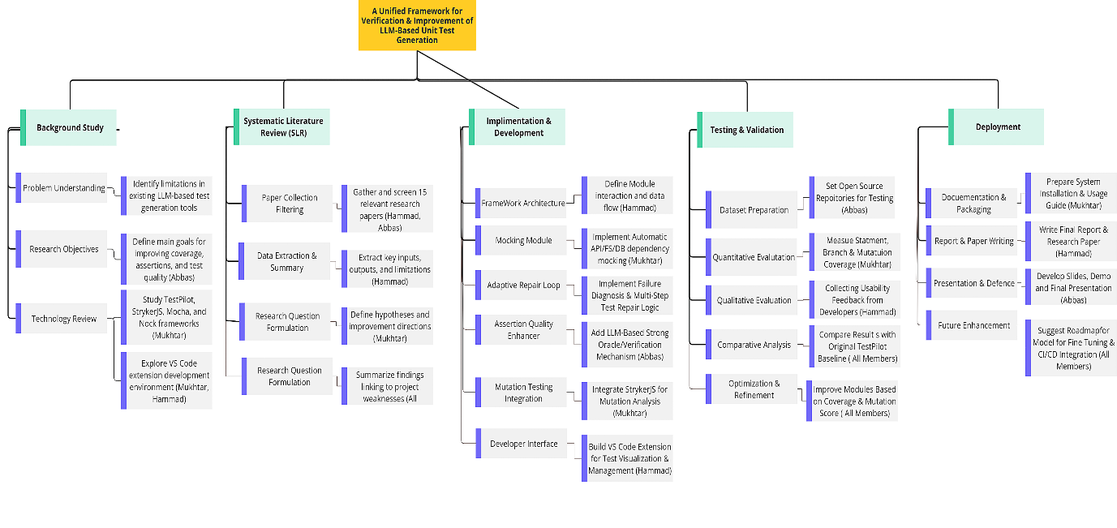
Figure 3 Work Breakdown Structure

Project Time Line
The project spans from October 2025 to June 2026, encompassing research, design, implementation, evaluation, and documentation phases. The timeline begins with problem identification, literature review, and framework design, followed by phased implementation that integrates mocking, adaptive repair, assertion enhancement, and mutation testing. Subsequent stages include empirical evaluation using the TestPilot framework, refinement through performance tuning and user feedback, and final documentation and defense. Responsibilities are distributed equally among team members: Abbas, Mukhtar, and Hammad to ensure balanced progress and consistent development throughout the project lifecycle as shown in figure 4.
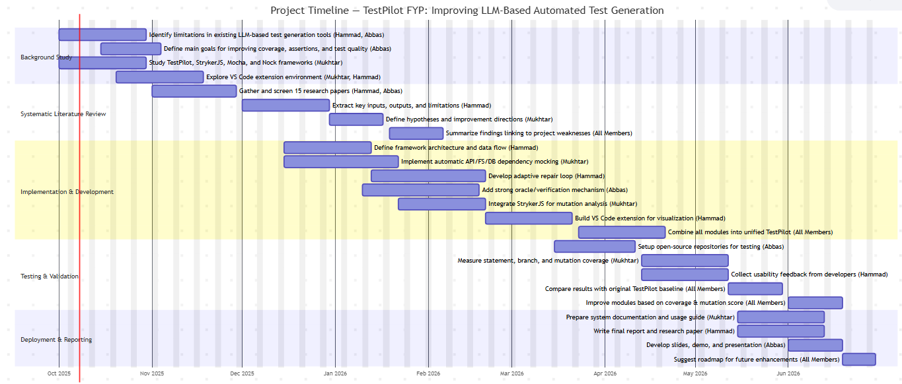
Figure 4 Gantt Chart

References
[1] M. Schäfer, S. Nadi, A. Eghbali, F. Tip, “An Empirical Evaluation of Using Large Language Models for Automated Unit Test Generation”, IEEE Transactions on Software Engineering, vol. 50, no. 1, pp. 85–105, Jan. 2024.

[2] G. Petrović, D. Ivanković, G. Fraser, R. Just, “Practical Mutation Testing at Scale: A View from Google”, IEEE Transactions on Software Engineering, vol. 48, no. 10, pp. 3900–3912, Oct. 2022.

[3] A. B. Sánchez, P. Delgado-Pérez, I. Medina-Bulo, S. Segura, “Mutation Testing in the Wild: Findings from GitHub”, Empirical Software Engineering, vol. 27, no. 132, pp. 1–35, Jul. 2022.

[4] A. B. Sánchez, J. A. Parejo, S. Segura, A. Durán Toro, M. Papadakis, “Mutation Testing in Practice: Insights from Open-Source Software Developers”, IEEE Transactions on Software Engineering, vol. 50, no. 5, pp. 2337–2349, Jul. 2024.

[5] S. Alagarsamy, C. Tantithamthavorn, A. Aleti, “A3Test: Assertion-Augmented Automated Test Case Generation”, Information and Software Technology, vol. 176, Art. no. 107565, Aug. 2024.

[6] B. Mali, K. Maddala, V. Gupta, S. Reddy, C. Karfa, R. Karri, “ChIRAAG: ChatGPT-Informed Rapid and Automated Assertion Generation”, arXiv preprint arXiv:2402.00093, 2024.

[7] F. Tip, J. Bell, M. Schäfer, “LLMorpheus: Mutation Testing using Large Language Models”, IEEE Transactions on Software Engineering, vol. 51, no. 6, pp. 1645–1665, Jun. 2025.

[8] J. Park, S. An, D. Youn, G. W. Kim, S. Ryu, “JEST: N+1-Version Differential Testing of JavaScript Engines and the Specification”, in Proc. 43rd IEEE/ACM International Conference on Software Engineering (ICSE 2021), 2021, pp. 156–157.

[9] M. Olsthoorn, D. Stallenberg, A. Panichella, “SynTest-JavaScript: Automated Unit-Level Test Case Generation for JavaScript”, in Proc. ACM/IEEE Intl. Workshop on Search-Based and Fuzz Testing (SBFT 2024), Apr. 2024, pp. 1–4.

[10] D. Stallenberg, M. Olsthoorn, A. Panichella, “Guess What: Test Case Generation for JavaScript with Unsupervised Probabilistic Type Inference”, in Proc. 14th Intl. Symposium on Search-Based Software Engineering (SSBSE 2022), Lecture Notes in Computer Science, vol. 13711, pp. 67–82, Nov. 2022.

[11] Y. Chen, Z. Hu, C. Zhi, J. Han, S. Deng, J. Yin, “ChatUniTest: A Framework for LLM-Based Test Generation”, in Proc. 32nd ACM SIGSOFT Intl. Symposium on Foundations of Software Engineering (FSE 2024), Demo Track, Jul. 2024.

[12] L. Yang, C. Yang, S. Gao, W. Wang, B. Wang, Q. Zhu, X. Chu, J. Zhou, G. Liang, Q. Wang, J. Chen, “On the Evaluation of Large Language Models in Unit Test Generation”, in Proc. 39th IEEE/ACM Intl. Conference on Automated Software Engineering (ASE 2024), Nov. 2024.

[13] S. Primbs, B. Fein, G. Fraser, “AsserT5: Test Assertion Generation Using a Fine-Tuned Code Language Model”, in Proc. 17th IEEE Intl. Workshop on Automating Software Test (AST 2025), 2025, pp. 12–23.

[14] Z. Nan, Z. Guo, K. Liu, X. Xia, “Test Intention Guided LLM-Based Unit Test Generation”, in Proc. 47th IEEE/ACM International Conference on Software Engineering (ICSE 2025), 2025.

[15] Y. Wang, C. Xia, W. Zhao, J. Du, C. Miao, Z. Deng, P. S. Yu, C. Xing, “ProjectTest: A Project-level LLM Unit Test Generation Benchmark and Impact of Error Fixing Mechanisms”, arXiv:2502.06556, 2025.

[16] Myers, G.J., Sandler, C., & Badgett, T. (2011). The Art of Software Testing. Wiley.
[17] Pressman, R.S., & Maxim, B.R. (2020). Software Engineering: A Practitioner’s Approach. McGraw-Hill.
[18] Rafiq, M., et al. (2021). “Automation of Acceptance and Integration Testing in Agile Environments.” IEEE Access, 9, 115732–115745.
[19] OpenAI, “GPT-3.5 Turbo Model,” OpenAI Platform Documentation, 2024. Available: https://platform.openai.com/docs/models/gpt-3-5. Accessed: Oct. 3, 2025.
[20] Y. Wang et al., “CodeT5+: Open Code Large Language Models for Code Understanding and Generation,” arXiv preprint, arXiv:2305.07922, 2023.
[21] L. Allal et al., “StarCoder: May the Source Be with You!,” arXiv preprint, arXiv:2305.06161, 2023.
[22] Meta AI, “Introducing Code Llama, a state-of-the-art large language model for coding,” Meta AI Blog, August 24, 2023. Available: https://ai.meta.com/blog/code-llama-large-language-model-coding/. Accessed: Oct. 3, 2025.

